Autoportraits from an Earlier Era

1. The *res poetica*

2. The stomach in Coriolanus

3. Huyghe downtown

4. My erotic double

5. Camping

6. Value

7. Whistle-blower

8. Transparency

9. The world’s energy problems

10. Doubt on the part of scientists

11. Agonistics

12. Positron Emission Tomography

13. Untitled (David Marr)

14. J.L. Godard’s *La Chinoise*

15. What did they use to cut paper in ancient Rome?

16. Nocturnal threshing

17. Second Schädel

18. Neo-Malthus

19. Zero point

20. A month of Sundays

21. Koop!

22. Full derivation with an opaque vowel

23. Bouleversement

24. The prince

25. A footpath

26. Junction

27. Redistribution

28. John Jay

29. Whimsical packet

30. Movement

31. Why it seems strange to you

32. Cerberus

33. Circumspection

34. The personalist school

35. Cat Washington

36. Commuter Train

Michael Scharf

Spring 2015The *res poetica*

1.

A *relation* is a real thing, i.e. has a physio-neuronal

instantiation between minds and in brains,

traceable through Positron Emission Tomography.

The*res poetica* is a relation realized through poetry.

It’s a space akin to what George Oppen

had in mind when he, following Shelley,

called poets “the legislators of the unacknowledged world.”

It’s not like “a city upon a hill” (which “cannot be hidden”).

2.

Poets are real: poets make poetry, or its algorithms;

they think of themselves, and represent themselves,

as poets.

Poets can’t help making poetry.

The *res poetica* is the set of relations poetry creates, affirms, or destroys.

In defining the limits of the *res poetica*,

place Wallace Stevens’ claim “We live in the mind”

beside Elaine Scarry’s demonstrations of the ways mind

can be reduced, with violence, to body.

3.

Poets come out of what Bishnupriya Ghosh calls “local struggles”

which cannot be represented from any one perspective.

The poem constructs a perspective on local struggles through the *res poetica,*

which brings together medium, author and author function,

reader and readers, reception conditions, text, performance,

and other poems.

It’s a model state that is momentary, fragile, propositional,

temporally continuous or discontinuous,

but materially real.

It is not different in kind from what happens

within the nationalisms Benedict Anderson describes in *Imagined Communities*,

or during the prayers Warren L. D’Azevedo describes in *Straight With the Medicine,*

or within constructs such as “The United States” or “India”

(which Narendra Modi describes as having a “natural relationship”).

It’s just differently realized, and enforced.

FORM IS NEVER MORE THAN AN EXTENSION

OF CONTENT, and it is thus open to evaluation.

4.

Anne-Lise François, following Eve Kosofsky Sedgwick, calls an *open secret*

“[a] gesture of self-canceling revelation [that] permits a release

from the ethical imperative to act upon knowledge”

in environments of threat.

An open secret is “an essentially preventative or conservative mode of communication

that reveals to insiders what it simultaneously hides from outsiders,

or, more specifically, protects them from what it is in their power to ignore.”

Poetry can be an open secret,

“a way of imparting knowledge

such that it cannot be claimed and acted on.”

As an open secret, poetry “makes nothing happen.”

“No

one listens to poetry.”

Poetry can recycle existing control structures.

The *res poetica* can take oppressive forms.

The *res poetica* can also transmit and maintain knowledge

in the face of tacit or explicit threat,

through articulation, or non-articulation,

within poetry.

5.

Vivek Narayanan characterizes Shrikant Verma’s *Magadh*

as “one of the most highly regarded books of Hindi poetry from the 1980s”

and “among the best books of poetry I have ever read.”

*Magadh* contains “ambiguous invocations of half-mythical South Asian cities”

that remind Narayanan of Borges and Cavafy, but

“there is also a canny and even bitter political outrage”

that makes me think of Mandelstam, and of Robert Duncan’s *Passages*.

Narayanan reads *Magadh* as an open secret:

“Bizarrely, Verma was a senior Congress Party functionary

under Indira Gandhi in the late 70s and early 80s”

which entailed mortal complicities.

“It’s hard, for me at least, to resist reading *Magadh*

as his way of speaking about some aspects of that close-up experience

in the only way he could.”

6.

Corpses in Kashi

Have you seen Kashi?

Where corpses come and go

by the same road

And what of corpses?

Corpses will come

Corpses will go

Ask then, whose corpse is this?

Is it Rohitashva? No, no

all corpses cannot be Rohitashva

His corpse, you will recognize

from a distance

and if not from a distance

then from up close

and if not from up close

then it cannot be Rohitashva

And even if it is,

what difference

does it make?

Friends, you have seen Kashi

where corpses come and go

by the same road

and this is all you did –

made way and asked,

Whose corpse is this?

Whoever it was

whoever it was not

what difference did it make?

— Shrikant Verma

trans. by Rahul Soni

9.

Despite Auden’s epithet and Spicer’s uncharacterizable lament,

the *res poetica* is a state discernible

as what Mina Loy called “the level of cool plains,”

a kind of transcendence that David Kyuman Kim identifies as religious,

but that can also be sexual, political, or otherwise determinate.

Like sex, political action, and religion, poetry, and the agency it affords,

is not the province of the individual.

It’s always built on local struggles, even when poets attempt

to contract their perspectives.

8.

According to the Stanford Encyclopedia of Philosophy,

“[t]he nebulous core shared by all cosmopolitan views

is the idea that all human beings, regardless of their political affiliation, do

(or at least can) belong to a single community,

and that this community should be cultivated.”

Seyla Benhabib contends that “since the UN Declaration of Human Rights in 1948,

we have entered a new phase in the evolution of global civil society,

which is characterized by a transition from international to cosmopolitan forms of justice.”

Benhabib notes that “whatever the conditions of their legal origination,”

cosmopolitan forms of justice “accrue to individuals as moral and legal persons

in a worldwide civil society… their peculiarity is that they endow individuals

rather than states and their agents with certain rights and claims.”

Cosmopolitanism seeks to transcend the state via ideas of individual natural rights.

10.

Bishnupriya Ghosh critiques Arjun Appadurai’s opposition

of “ethnic collectivists who lack… global imagination”

to cosmopolitans who, by contrast,

“relish non-national nomadism and celebrate migrancy, hybridity, and mobility.”

Ghosh cites the critiques of Revathi Krishnaswamy and Aihwa Ong,

who find such formulations of cosmopolitanism reflect

the experience of “transnational elites” who “fetishize their marginality as migrants,

while synchronizing the global flows that underpin the new world order.”

Addressing a body called “The International Agency for Cities of Refuge,”

Jacques Derrida, elaborating an idea of cosmopolitanism,

at a conference on “The Charter of Cities of Refuge,”

finds that the conference-goers have defined for themselves

the task of “bring[ing] about the proclamation and institution of numerous,

and, above all, autonomous, ‘cities of refuge’, each as independent from the other

and from the state as possible, but, nevertheless, allied to each other

according to forms of solidarity yet to be invented.”

12.

Sheldon Pollock writes against “what often seems to be the single desperate choice we are offered:

between, on the one hand, a national vernacularity dressed in the frayed period costume

of violent revanchism and bent on preserving difference at all costs and, on the other,

a clear-cutting, strip-mining multinational cosmopolitanism that is bent,

at all costs, on eliminating it.”

Pollock wants to “conceive of the practice of cosmopolitanism as literary communication

that travels far, indeed, without obstruction from any boundaries at all,

and, more important, that thinks of itself as unbounded, unobstructed, unlocated —

writing of the great Way, rather than the small Place.”

At the same time, Pollock wants to “think about cosmopolitanism and vernacularism

as action rather than idea,

as something people do rather than something they declare,

as practice rather than proposition (least of all, philosophical proposition),”

and also as a *choice*, one which in turn “enables us to see

that some people in the past have been able to be cosmopolitan or vernacular

without directly professing either, perhaps while finding it impossible

rationally to justify either.”

At the time of its dominance, Latin

was a cosmopolitanist idiom, and English,

Spanish, German and Italian were vernaculars.

At the time of its dominance, Sanskrit

was a cosmopolitanist idiom, and Hindustani

Tamil, Kannada, Javanese, and Marathi

were vernaculars.

7.

Monolingual speakers of English can access re-representations of vernacular FORMS

but not the chains of meanings associated with them.

One recent response to lack of access to the conventional meanings

of, for example, Tamil film, is to use the tools at hand

to appropriate its forms into a superordinate neo-cosmopolitanist idiom,

via, for example, heightened cuts, homophonic subtitles, and pasted voice-overs,

which are forms of, among other things, simulating

accessibility and discursive mastery.

The failure of global capital to fulfill its implicit promise of total access

is not quite ironized in the work like this that I’ve seen,

which is more like a fetish.

The failure of a vernacular to signify outside of its domain

in made out, in this work, to be the vernacular’s problem,

its amusing deficiency.

The author function of the work can incorporate the ironies of that reading,

and try to make them reflect back on communication failure

within dominant modes, which produce (and this is what makes it lyric)

a kind of pathos, which can be beautiful.

The negotiations take place within the *res poetica*.

8.

I once published a poem that contained the following three lines

The Asian woman sat eating Tam crackers.

I laughed.

This stuff is endless.

When I first read the poem at Halcyon in Brooklyn in 2000,

a member of the audience had a visible visceral reaction,

and the *res poetica*, running like a current through that moment,

was damaged and reduced.

Poetry can, I guess, attempt to recapitulate and reiterate racist thought

without the poem’s author function seeming to be a node

for drawing pleasure in discharge from the thought itself,

but it requires permission, which can only be rendered

within the *res poetica*,

A whole movement in poetry developed out of that premise.

Or maybe it developed out of an ironic effort to drain the stereotypes of charge

by the act of drawing pleasure out of disgust in re-iterating them,

as a sign of self-implication.

Pleasure in disgust, and pleasure generally, can freak people out,

but deriving pleasure from disgust and deriving pleasure from re-iterating racist thought

probably can’t be distinguished.

The *res poetica* takes the place of intention.

10.

Poetry has its own particular modes of reception,

rather than a fixed and identifiable set formal characteristics.

Reception, as defined by Auerbach, is a “subjectivistic-perspectivalistic procedure,”

one that, under certain conditions, “creat[es] a foreground and a background,

resulting in the present lying open to the depths of the past.”

Despite the yucky metaphor, the procedure Auerbach describes

takes place within the *res poetica*.

Maharashtra was created in 1956,

four years after Nissim Ezekiel’s first book, *A Time to Change,*

was published, in English, the language in which it was written.

Ezekiel returned during this period from England to Bombay, where worked in close

touch with other writers.

Arun Kolatkar, 8 years younger than Ezekiel, published more than 15 books in Marathi.

He published *Jejuri*, his first book written in English, in 1976.

The book is a serial panorama of a sacred Hindu site in Maharashtra,

incorporating numerous ironies that play the site’s actual physical state

off its accepted spiritual significance.

Kolatkar’s second book written in English, titled *Kala Ghoda Poems,*

*(*after a district in Bombay now as gentrified as the West Village

or *le Marais*), was published in 2004, a year after his death.

His third, *Sarpa Satra*, a retelling

of a tiny piece of the *Mahabharata,* was published that same year.

Kolatkar’s writing in English was an open secret

whose nature is only beginning to become clear

in the lights of linguistic politics, Hindu and Maharashtrian nationalisms,

and various cosmopolitanisms.

Kolatkar’s Bombay is a city of refuge whose forms of solidarity

are now beginning to be realized within the *res poetica*.

Kolatkar’s poem “Pi-dog,” from *Kala Ghoda Poems*,

set in the Kala Ghoda section of Mumbai,

ends when day breaks, and, as in many cities in India,

the dogs, who have ruled small sections of the night roads,

“surrender the city

to its so-called masters.”

10.

Anne Boyer’s daughter recently said that the choices are

between shut-in or revolutionary.

The air has run out of the piety market.

The staging of voice can be a revelatory

model, opiate, refuge, by-product, or iteration,

for what it is worth.

***

“Metaphysical blippety-blips

while sucking candor lozenge?”

— “The Cosmopolitans”

Sianne Ngai and Brian Kim Stefans

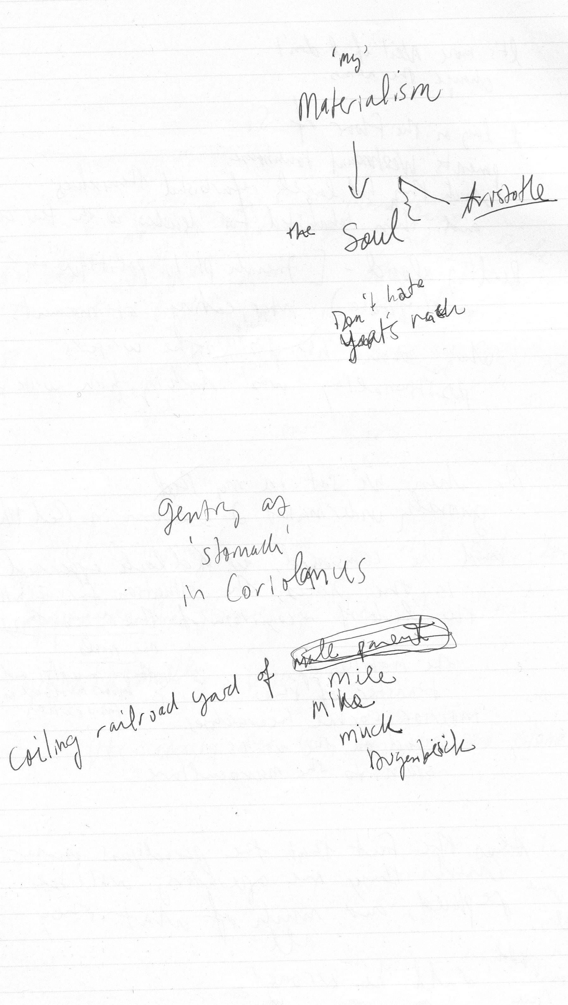

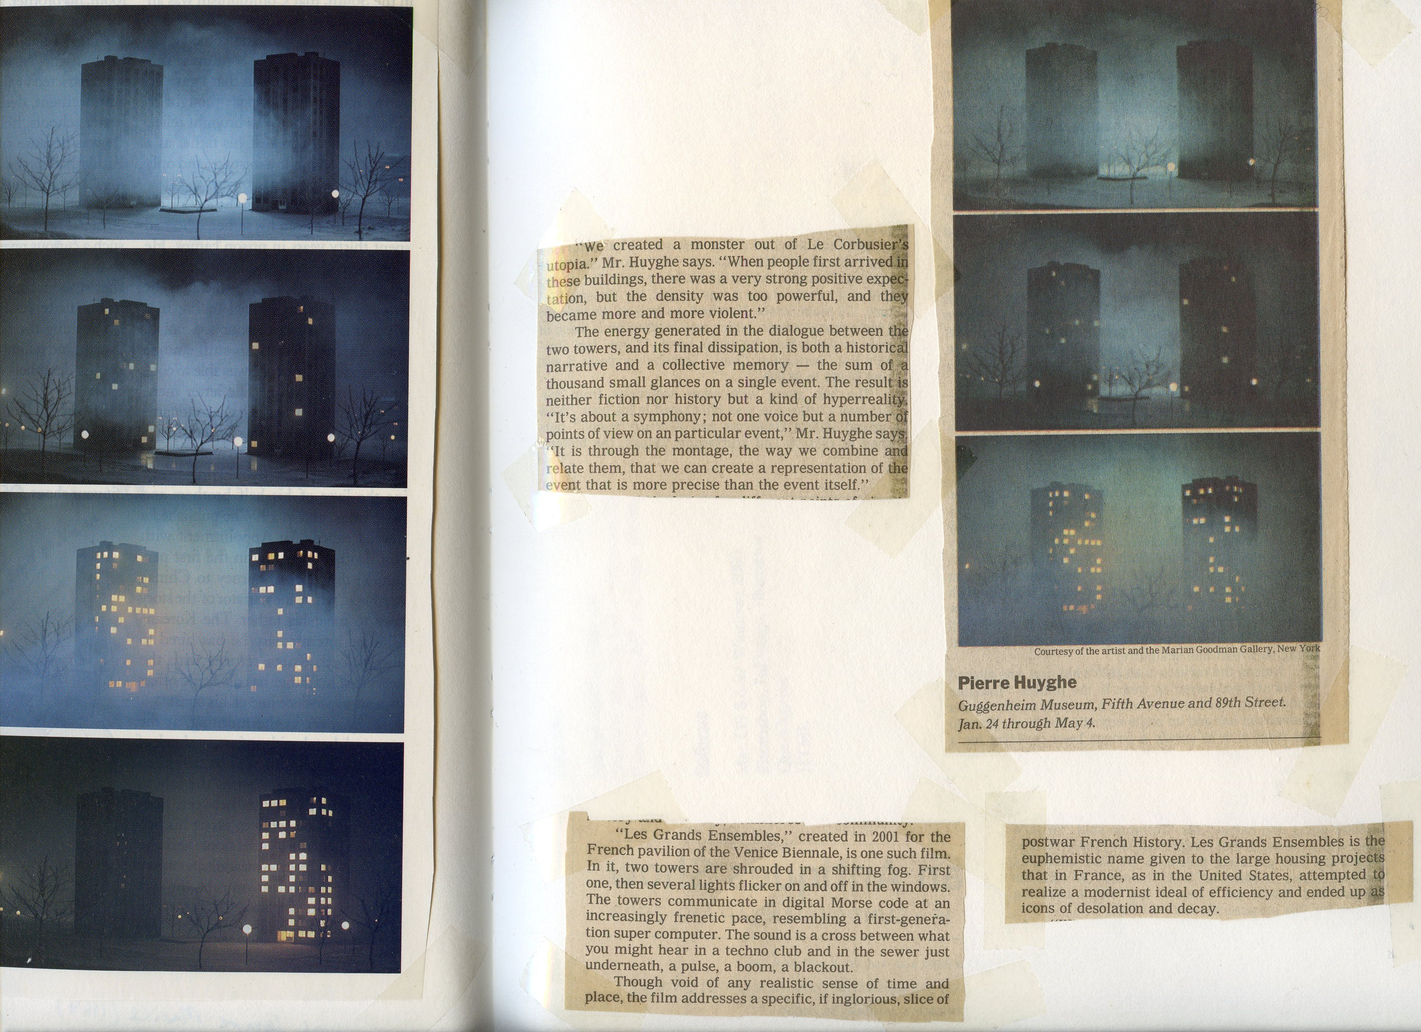

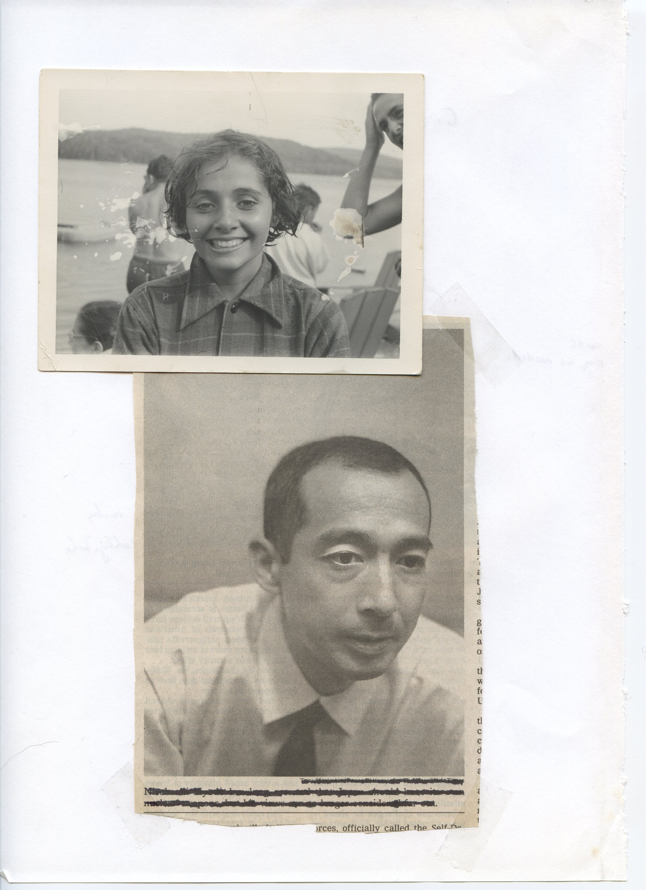

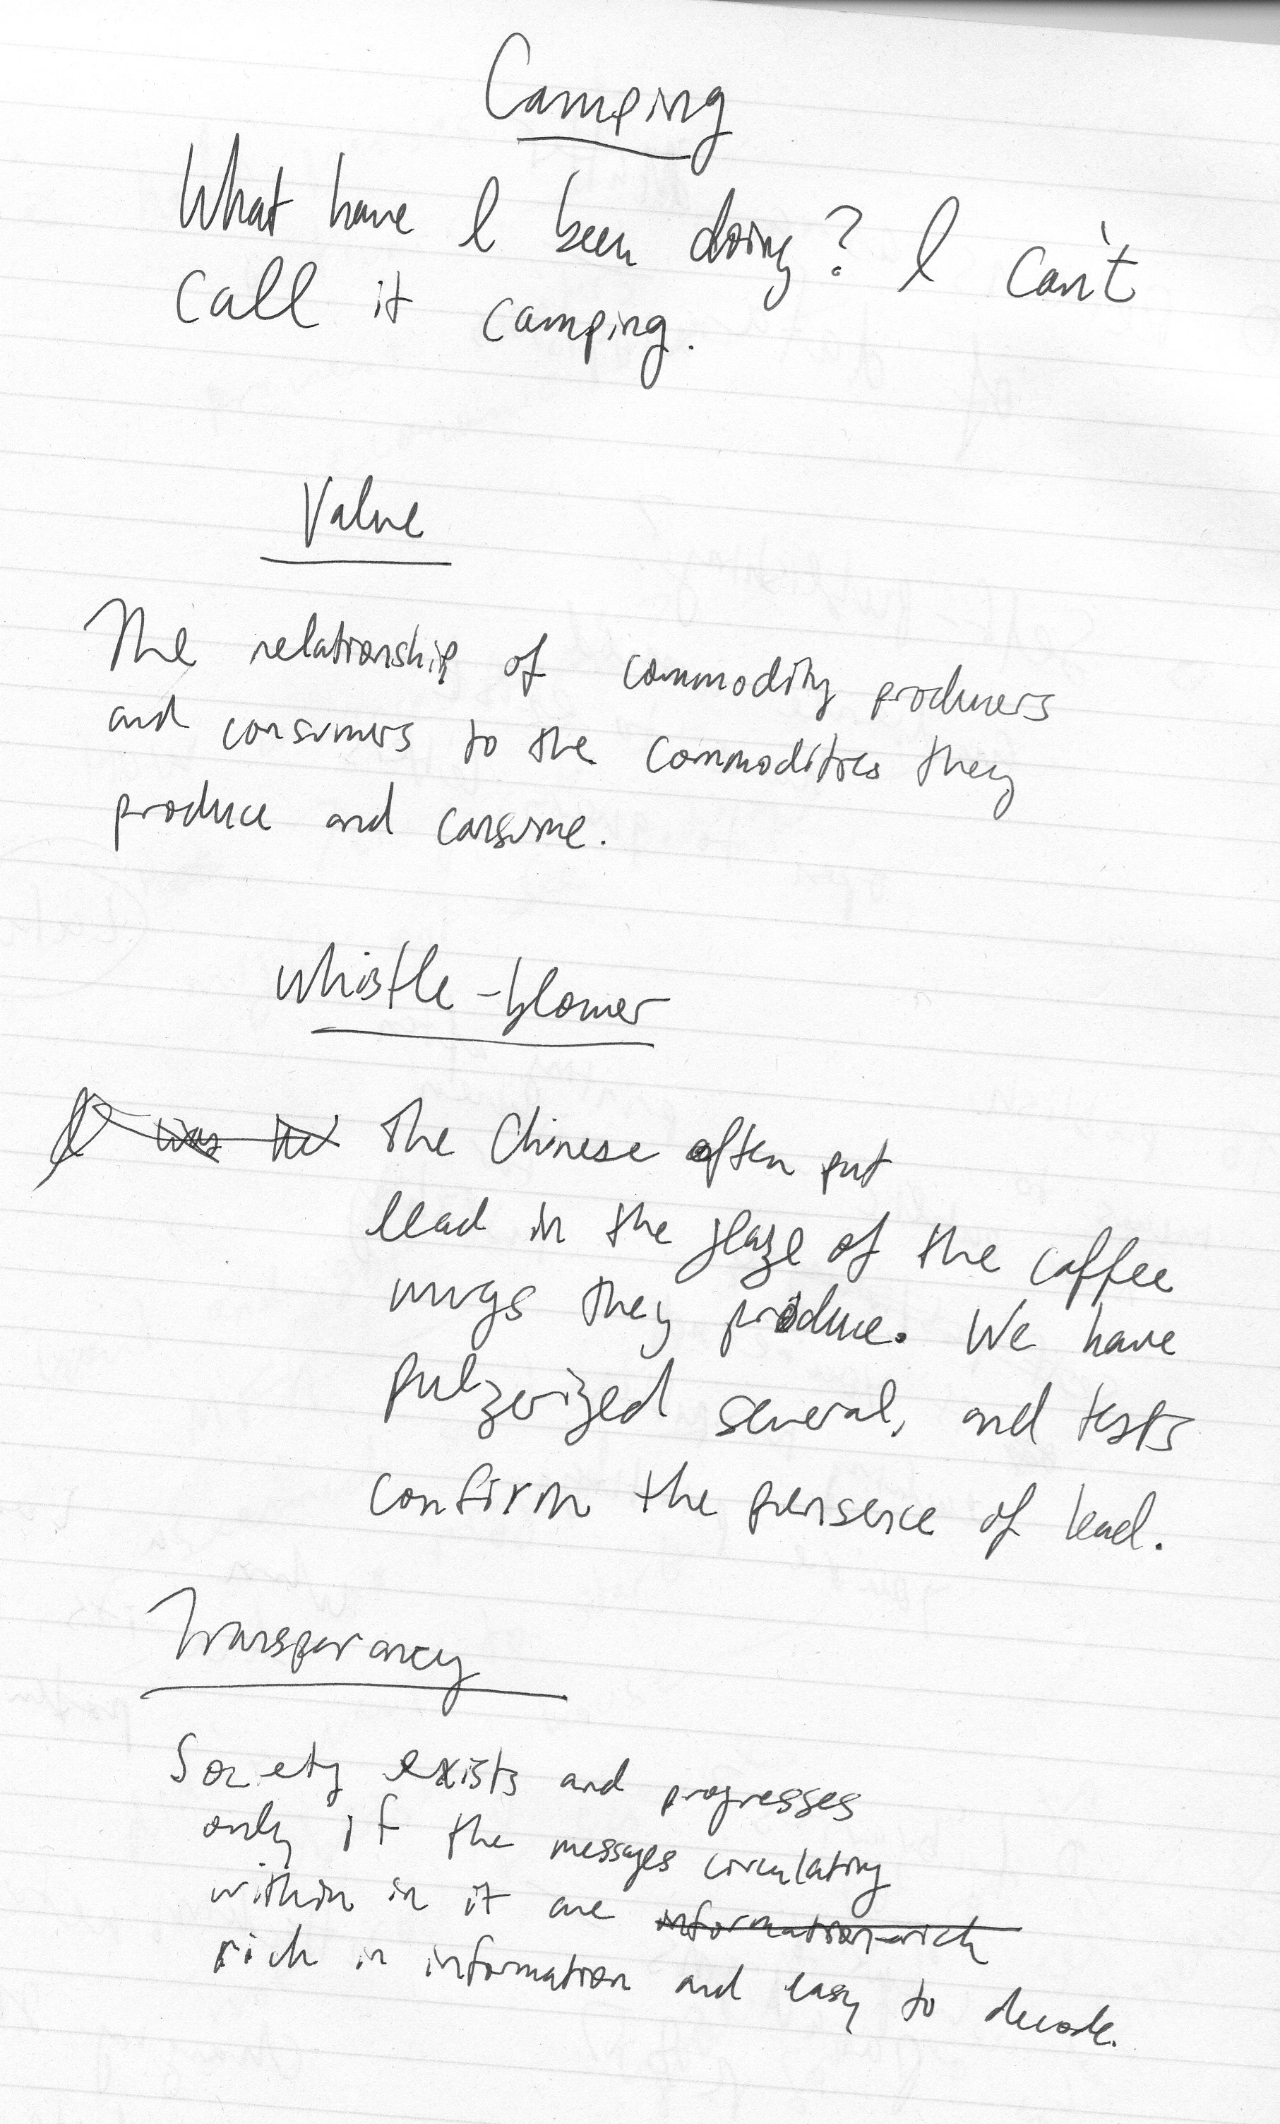

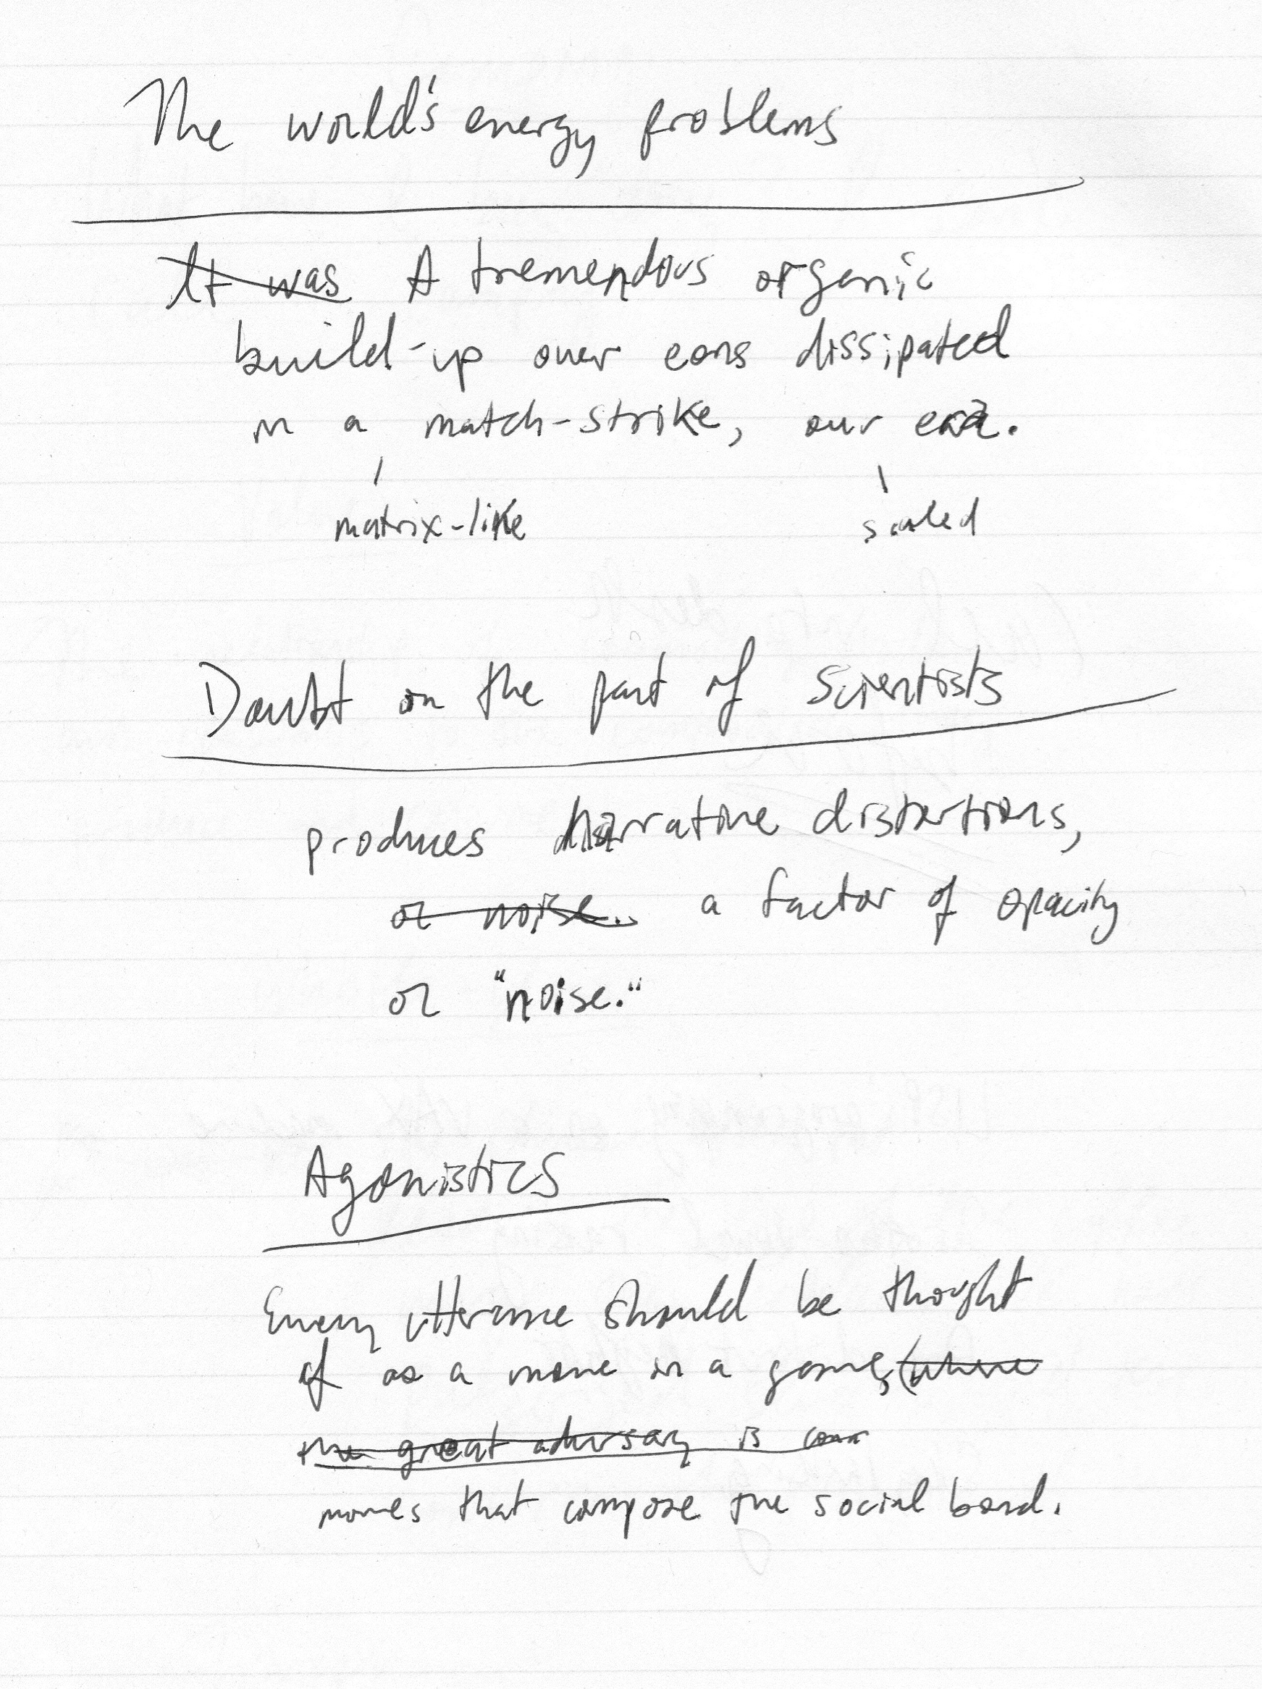

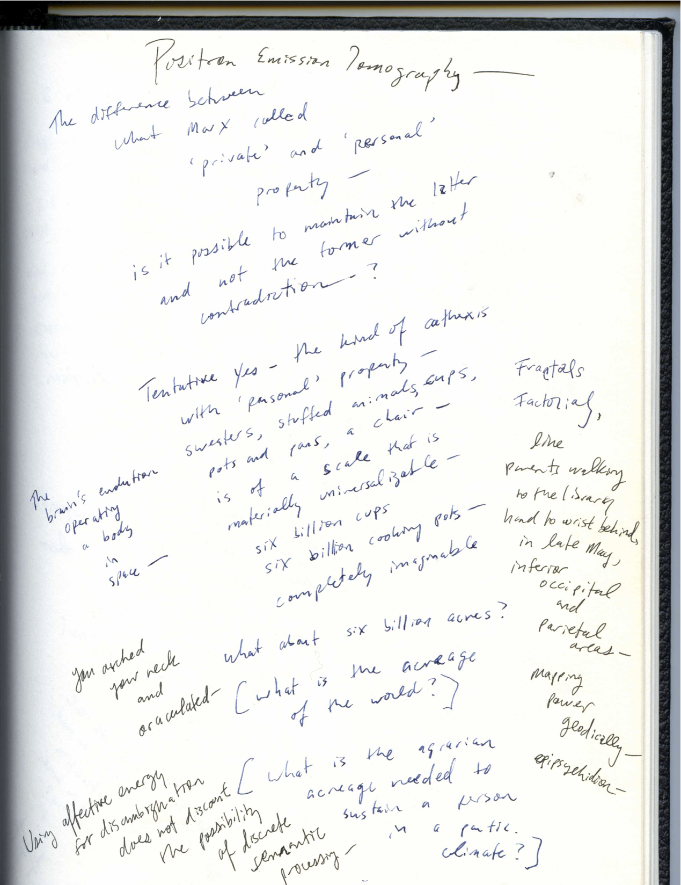

How many windows do I have to have open in order to make any

Passing

Marxist, *si marxisme = ..., alors je ne suis pas un*.

Marr, David. Eeyen.

Arit*c*les;

Poem Begnning ‘The’ as pinned wriggle;

rickles stickles rictus wrinkled scrunch of ‘the’

white medullafoldiana

which ric tickles you?

who tickles you? ric?

M is in Oman—[M’s update about Omanian Indian food] –

having flown into Dubai—[M’s pic of airport]

[Lunch at Saravana Bhavan before he leaving

no, at the place that’s now Tamil Nadu Bhavan alveolar “Tdahmil”,

reverse-engineering the braised cabbage with mustard seed,

and some Hasids came in, since it’s dairy.]

Mildred’s people and how dark they were Gwenne says and all die Mandelaugen and how

the Russian Jews were raped by Tartars and Mongols and Bashkirs

23 and me

unfulfilled cateyed midwestern step-great-grandmother.

Published, like finch down, en deux, meaning that both will, toward death, be forever

linked,

Like the horrid backing vocals on the fourth track of *Ys*, sounds like she replied

"suck my dick on a cherry stone," as if they’re facing each other naked on a cherry stone

do you masturbate to vinyl exclusively, produce your own record cleaner, having drawn,

from the coal-burner, white drips that fall back and settle inside a clean behind.

Steve gives a cat toy to my heart.

Terence Stamp Terence Mallick, Terence nihil human alienum est.

Or Kazars disproven are 'we' Kazars, and who Tankoos, Graecius,

the pure sun who throws off, throws the giraffe in the liffey, protesting his innocence

And George Steiner talking about who, about the poems that might now, may now, might now,

might now not, may not now, now have,

Here's the humidifier,

itch on the supple skin of the hips,

Third wheel, fifth column,

bicycle, car, two triangles

carmel, caramel, camel, pack,

oaxaca, nulle part, bulle ogier

Most of B incommunicable and Deiharryyrdre

gives me the enzyme

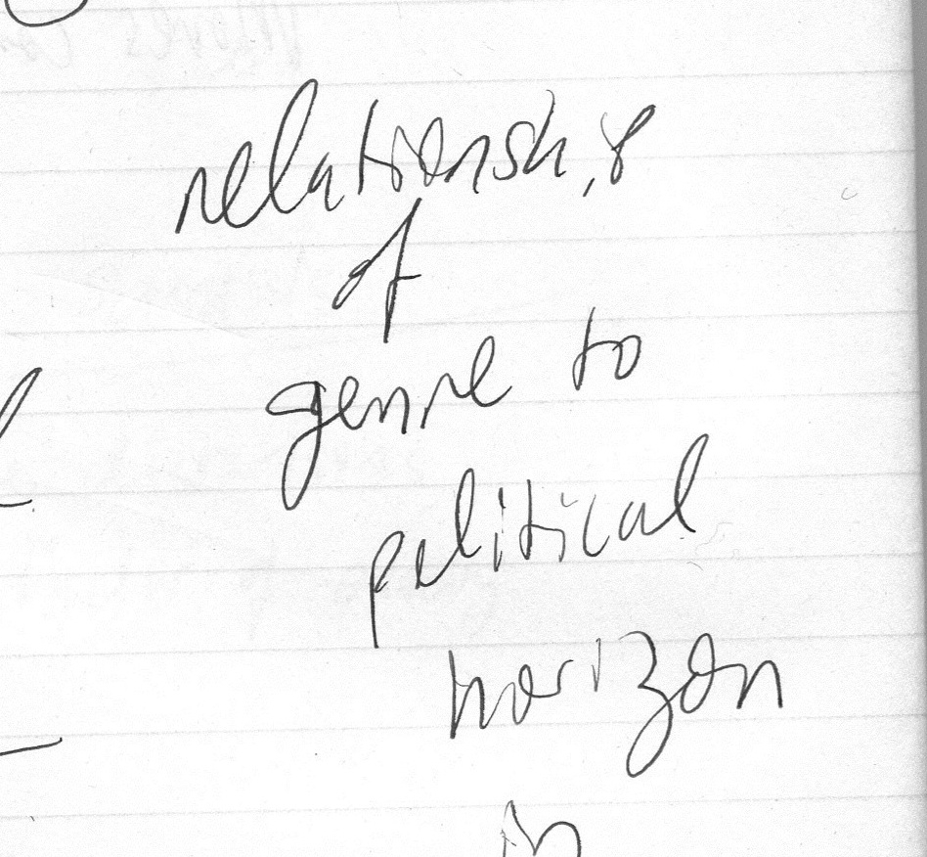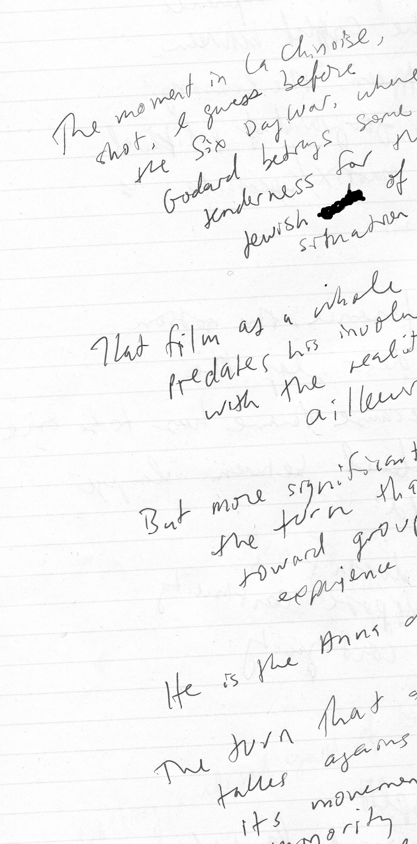

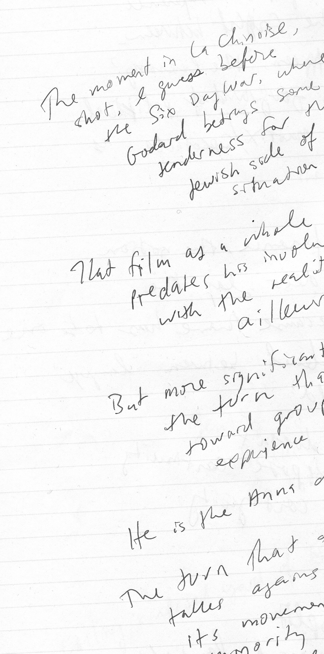

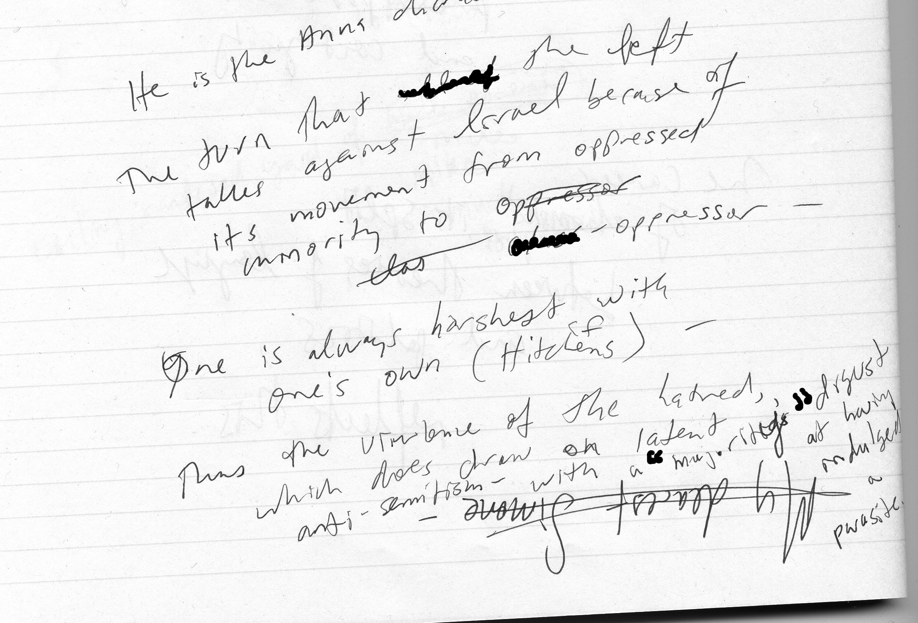

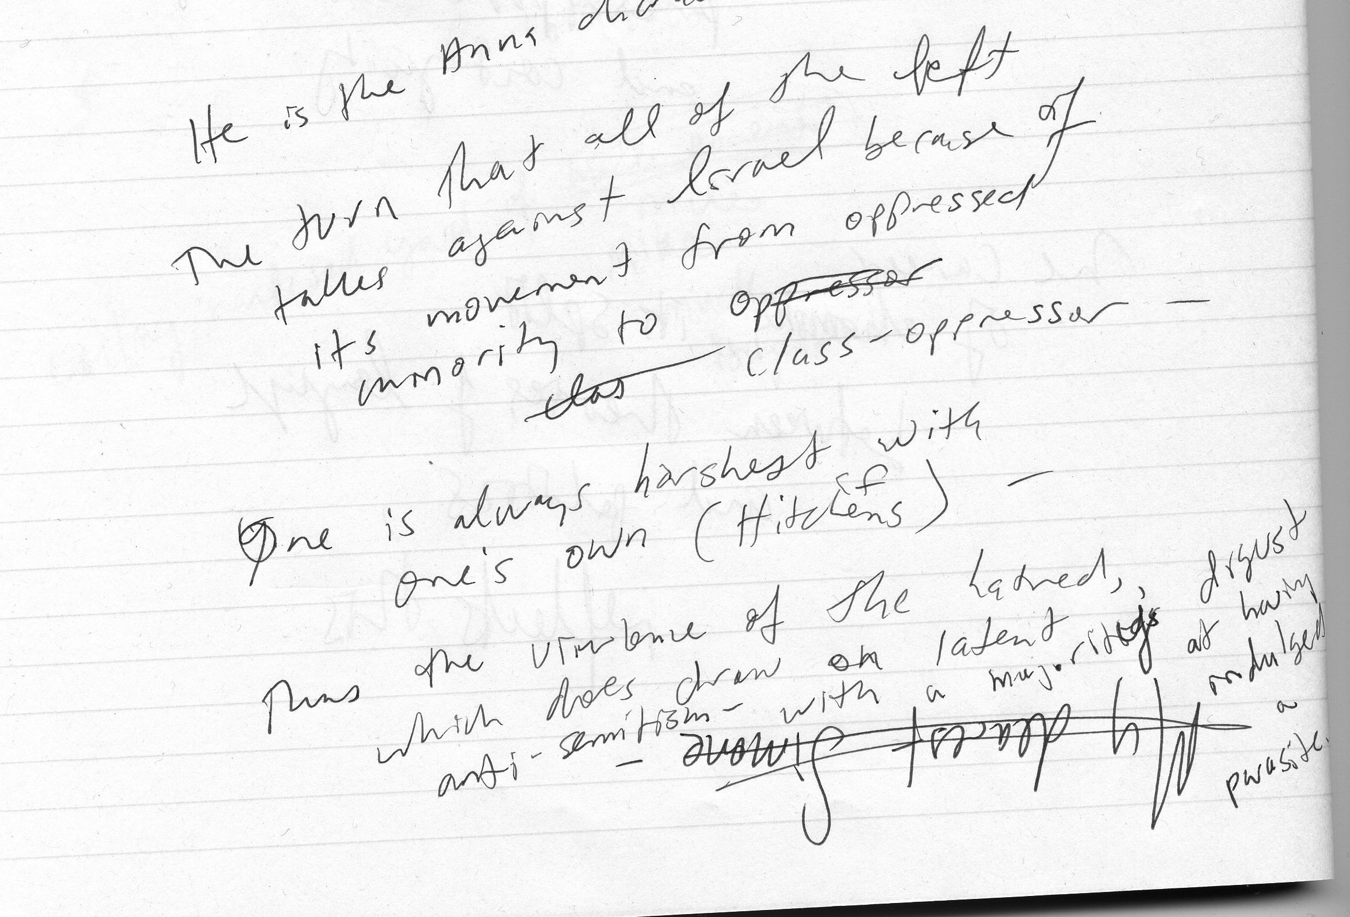

What Did They Use to Cut Paper in Ancient Rome?

A caesars

which really troubles

Alfred,

Lord

Tenny Pump

unquantifiably

to which to wit,

‘razors’

‘barrels’

‘contortions’ -

confounding liquids

and nasals.

Ok,

Heaviest one-syllable word

in English?

Strengths.

Heaviest rock in English canon?

Badger.

Nocturnal threshing

My hands enter the water and sort of separate

the wheat, gold and granular in the water.

It does not get cold enough anymore

to freeze the leaves. The pane shakes.

Nay saying bedside warm click of the lamp,

the yellowed shade, or melted yellow plastic top,

lets hair down to the mats on the floor. Climactic

sets of images to be read off as circled, spoked,

tuned, forced. The teeth of each

winding gear gapped, spaced unevenly, w/o

two quarters to rub together in i/o

folderol twiggy, jerry, quoit,

let it down

(“let down

uneas

ily”)

Several inhaler, Creation of evidence

spring injector, by stranded

false leads. sample.

Cloudy water

in the same beaten

pans. Red rice

floating

husks. Cast

alloy.

Second Schädel

The land’s a pocket mirror; you like to hold it down

and catch flashes of yourself.

It’s teeming. Greenpoint burns off its relations.

It’s a rimless procession: the sun, unbound but forced to sphere,

tentacles marble, an absorptive French blue, with particles

rising and falling in tandems, lolling in arcs.

Walking past the plant on Meserole, foot

blanket tangles and lips come down, calcium white.

Steam comes out the windows. It smells of perc.

Neo-Malthus

The neo-Malthusian, generally

alarmist story about human eco-destruction,

of which neither economic optimists

nor distributionists (meaning those

who would like to see the square footage spread out

rather than reconcentrated) have folded into recent findings

about thresholds, interdependence and interactivity,

can’t account for the disruption of ingenuity in environments

of scarcity. The violence of the appropriation of science is counter-

balanced by a need to get the word out, the reflexive digression

a needed point of rest. Similarly, the production of perverts

like Balthus an economic effect, one that has shifted

as the bourgeoisie elevates directly to gentry, already

in motion before, as evidenced by the spectacle of Lizzie’s

purge, staged by agents told by Massoud to stay home

from Conscience Point that night. Explain that. Easy.

Contextual pressure nudges toward the quick hits:

homemade rockets, hilltop bionics, and superraytheonics.

Zero Point

Leading edge charged to millions of volts,

trailing edge charged to millions of volts—

Spectacle of youth-driven memory

remains acquisitive during development,

adding and storing complex

behaviors and symbol sets destined for—

planned obscenity material—arrival.

Witnesses distracted as much as possible as

predecessors obliterated,

capacities for bio-powered beat-based behaviors

form the basis of distant

mutations,

fatal adaptation

to Fordism.

Coats are not exchanged for coats

and your exigency cannot confront me directly

smashing skulls on the ice repeatedly

to facilitate carbon dating of a single example,

relentlessly cited.

Five people not destroyed by their jobs;

five animals destroyed.

*

Brains wired for incredible violence

produced directly, cut, packaged,

shared and exported,

or hidden and

lied about, whatever.

Each ‘culture’ its own dissimulation or virtual machine

from extrémiste litérateur to practiced flak

to family adviser

it really works

just putting it out there

Parallel states

planes above

casting uniform

thus difficult-to-detect shadows

over and rays onto

the depleted skein

never actually deployed:

structures of representation

rule of law

terms of citizenship

intercourse between planes constant, vacuum between planes

sexless, and violent under development

and though the lower

be degraded to countervailing

construct or ‘pressure valve’,

enough energy

at points of contact

to boil the oceans six thousand times.

Just as a twist of the knob from 60,000 feet

rearranges the village or Syrianan contact among princes

and operatives,

scaled-down attacks allow discourse

to prepare the ground

where poetry can still operate

make form like choice.

For Douglas Rothschild

For Nick Cook

A month of Sundays

Sunday

All de Chirico. Limp glove. Moist. Kalt. Vaca. Late de Chirico. Still. Stay in your plaça. Hanging. Four boys huddled under a scaffold. High. Exit ramps like ram’s horns. Stay real. Contribute carbon. Card. Slot. Hot. Bot. Cot. Cod. Tot. Todt. Tris. Toll. Tam. Tap. Toe. Poll. Poe. Pee. Pop. Pin. Clouds like needles. Clouds like explosions. Like expositions. Like roses. Like containers. Like pilots.

Sunday

I had tris in my pajamas.

Sunday

You can’t say pilots anymore.

But notice

how you can say roses.

Malbecfast of Champions

Punto Pays 2005.

In a big country, dreams.

Koop!

Er, flown the? Nay,

it’s what they say

on the train to Oostende

to collect the fare.

Er hat,

said the German

in the next compartment

after I reached for my wallet

and touched her hair.

Hazel.

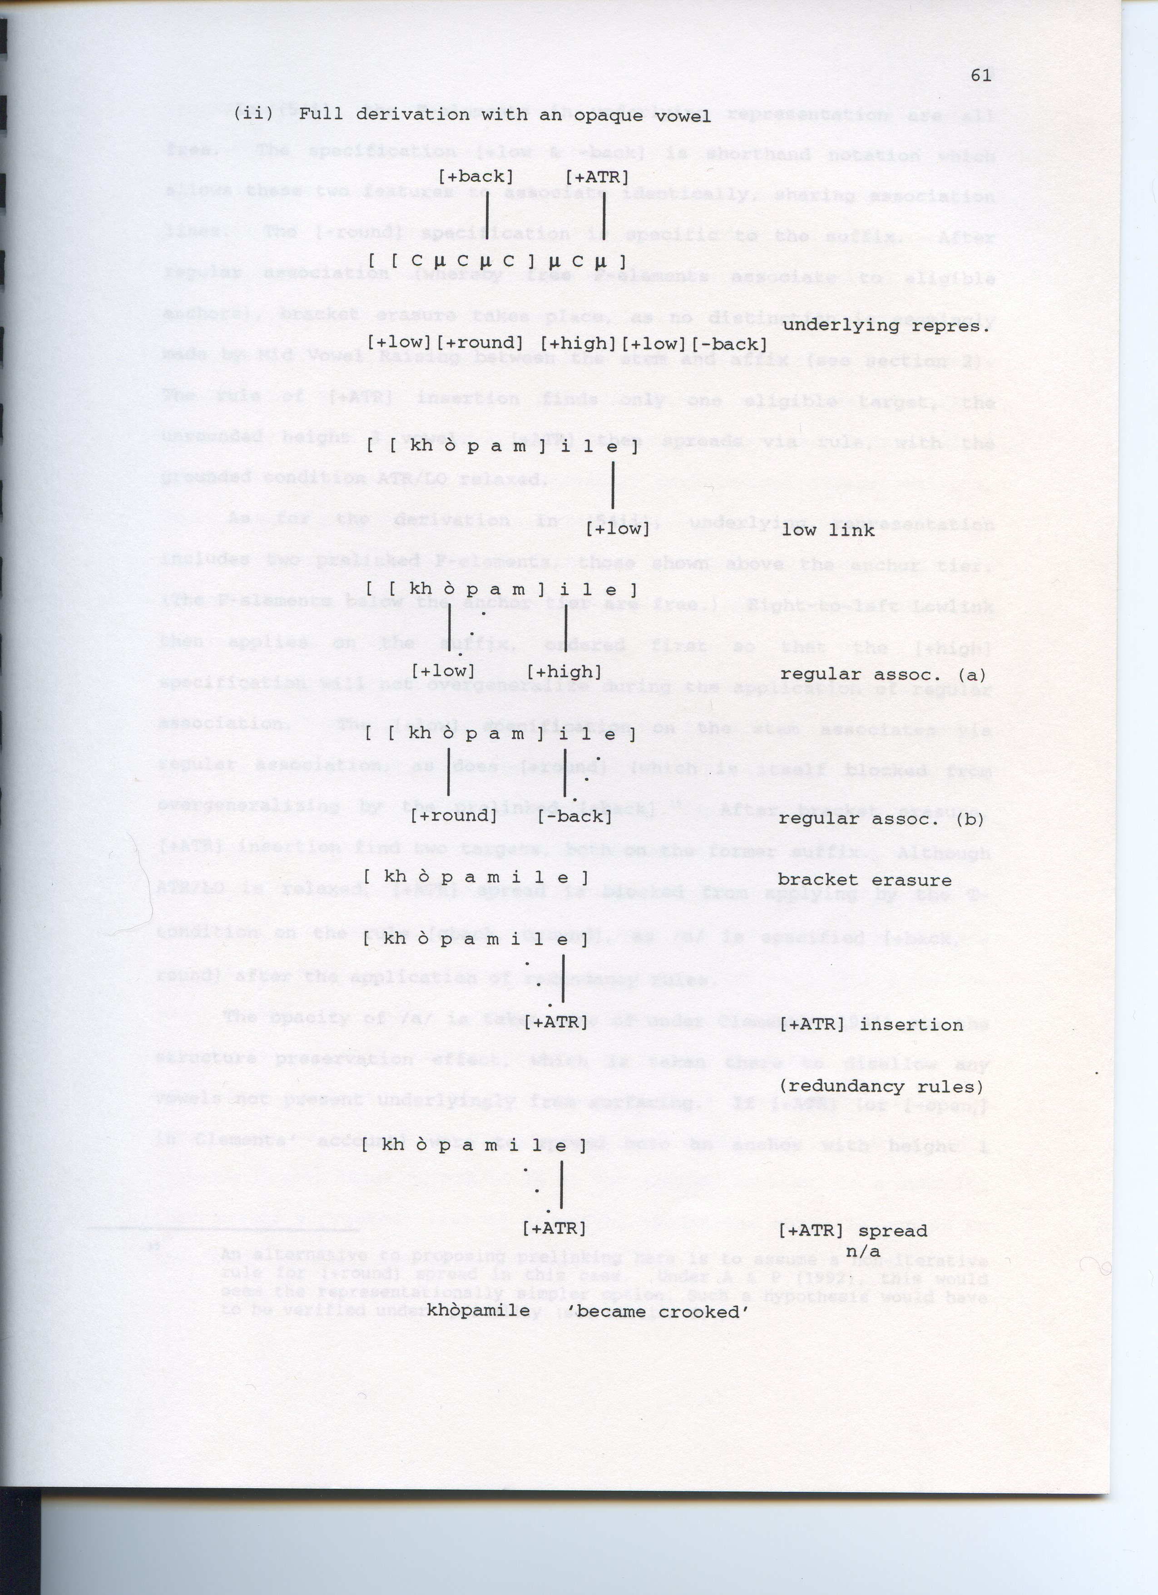Bouleversement

A golf club

shoved

upside down

down the length

of the esophagus ---

club head just showing

thought the teeth

Apartment-dwellers

in contractor’s bags

piled at curb for 12:30am

pickup

Other bags, filled just with blood,

opaque,

bulging, misshapen on the pavement,

drained for sodium

and pumped into

the streetlights

All the city’s dogs

electrocuted and left stiff,

piled.

Elevators run on long cords

in whatever direction they are needed.

The Prince

The prince of

    the primitive

      society touches

          his cousin,

       the princess,

        with impunity.

A functioning Presbyterie

     heightens its

         men’s cries.

Everyone is

   getting touched

        in Mysore.

I make films

    in which I fuck

        Indian

          girls.

A Footpath

A footpath in Mawkynriew. A brighter brown than Roland Garros.

We are all of the view that the area is too congested, and as soon

as we can find a larger space to meet, we will move the group.

Junction

Power comes into the box

from the street. On into the building

from the street, then is split.

Boxed unexposed.

The wires underground spray sparks

within capped frays and insulation

thicker than thumbs.

Redistribution

You understand the reeducation committee;

you can understand me.

The level, and then the appeal

to equitable terms.

The white sauce thickened

by corn starch, the reduction

thickened by corn

starch, the reduction

of the stock.

Tracing out

the argument

as a contribution.

John Jay

Schools should teach procedurality &

paramilitary procedure, and science

should be based on health-care

chemistry and human cell functionality.

Whimsical Packet

Medical element, preserved

tentacles,

strung walls, busted

umbrellas, rice,

lobster claws

strained violin tops,

scrolls, shower

stars, lone peach with

blossom, S.A.

eggplant colored bath

sticky star, hanging

ice-cube like, isolated

flecks, evidence of scrapes,

more fruits and bursts

faded and distressed.

Movement

Instead of trying to undo

while ‘growth’ mimics

population,

You must have self-confidence

or you will make other people

feel stupid

for investing in you

Why It Seems Strange to You

Songs arrive at the moment

of emotional impasse, when canned dialogue

can’t sustain the emotions (thus, the plot),

when the characters ‘realize’ they

are in the thrall of bad terms

Cerberus

When death was a master and not a miasma, not a failure

of health care, the graveyard sat within the town, city, square block.

When, sickened, you turned your eyes up...

Fuck the ward and its beeps

night as it creeps

Circumspection

Circumspection

pushes outward

to assimilate

Fatted,

and then pushed

into higher state

hood

hoos

hodding handling

Es gibt

Il faut

To a fault

he crept

taken token

too closely

wrapped

in 3

1, 2

The Personalist School

Frank O’Hara’s “Personism: A Manifesto” (1959) can be read as a parody of a construct called Personalism, a meme from that era.

Gordon W. Allport (1897-1967) created and taught the course “Personality: its Psychological and Social Aspects” at Harvard in 1924.

The course was the first at a U.S. college to treat personality theory as a discrete branch of psychology.

Allport joined Harvard’s psychology faculty in 1930, and, in 1937, published Personality: A Psychological Interpretation, which became the standard U.S. textbook of personality theory.

By the time Allport’s 1954 book The Nature of Prejudice was released, psychology and psychoanalysis were being used to explain growing unrest in the U.S.

The book arrived at the beginning of the Civil Rights Movement, and sold more than a half-million copies in the U.S. over the next 25 years.

It describes “prejudice” in terms of “In-Groups,” “Out-Groups,” “ego defenses” and “rejection.”

When Allport’s Becoming: Basic Considerations for a Psychology of Personality was published the following year, it received more attention than a set of essays on personality theory normally would.

In Becoming, Allport elaborates the concept of the “proprium” (the container for personality) partially through “Personalism,” a long-extant philosophical construct with multiple contradictory meanings.

Allport’s Personalism describes every mental function as embedded in “personal life.” There is no separable symbol processing or space perception; there are only people who have senses, feelings, and impressions.

The Personologist, a real Allport construct, asks “How shall a psychological life history be written?” and “What are the individual consistencies?”

Depth psychology “may plunge too deep”; “being in the moment” and “being present” are the keys to psychotherapy and to development.

Allport used the terms “proprium” and “Personalism” to distinguish his constructs from the nascent “Self” psychology of Heinz Kohut (1913-1981), and from work by Abraham Maslow (1908-1970).

In a 1943 paper titled “A Theory of Human Motivation,” Maslow adopted Kurt Goldstein’s concept of “self-actualization” and placed it atop a “hierarchy of human needs.”

Maslow defines “self-actualization” as “the desire for self-fulfillment, namely the tendency for man to become actualized in what he is potentially.”

In Client-Centered Therapy (1951) by Carl Rogers (1902-1987), the “client,” who “has within himself or herself vast resources for self-understanding, for altering his or her self-concept, attitudes and self-directed behavior,” marshals resources that require “a definable climate of facilitative psychological attitudes” to add up to the “freedom to be.”

Allport’s “person” may have also been defined against Rogers’s “client.”

O’Hara, who graduated from Harvard in 1950, writes that he “founded” Personism “on August 27, 1959,” in conversation with Amiri Baraka.

“Personism: A Manifesto” was dated September 3, 1959 when it appeared in the magazine Yugen.

M.L. Rosenthal’s review of Robert Lowell’s Life Studies, titled “Poetry as Confession,” appeared in The Nation issue dated September 19, 1959.

Rosenthal chose the term “confession” to recall Lowell’s 1940 conversion to Catholicism, much discussed when Lowell won the 1947 Pulitzer Prize, at age 30, for Lord Weary’s Castle.

In his review, Rosenthal says that Life Studies contains the equivalent of “a series of personal confidences, rather shameful, that one is honor-bound not to reveal,” and that Lowell himself “seems to regard” the book as “soul’s therapy.”

In interviews at the time, Lowell said the composition of Life Studies was part of his psychotherapy.

“Everything is in the poems,” O’Hara says at the opening of “Personism,” “but at the risk of sounding like the poor wealthy man’s Allen Ginsberg I will write to you because I just heard that one of my fellow poets thinks that a poem of mine that can’t be got at one reading is because I was confused too.

“Now, come on. I don’t believe in god, so I don’t have to make elaborately sounded structures.

“I hate Vachel Lindsay, always have; I don’t even like rhythm, assonance, all that stuff.”

The reference to believers creating “elaborately sounded structures” is probably a reference to Lowell and the highly-wrought Weary, and maybe to T.S. Eliot.

Vachel Lindsay, who committed suicide in 1931 by drinking Lysol (“They tried to get me—I got them first!”), was known as a socialist, and a moralist: “Would I might rouse the Lincoln in you all!”

The parsing of poetic form using traditional metrics (rhythm, assonance) was a hallmark of the New Critics.

O’Hara often delivered similar ripostes to the generation just slightly older than his: “Memorial Day 1950” contains the line “Our responsibilities did not begin/ in dreams, though they began in bed,” which inverts Delmore Schwartz’s “In Dreams Begin Responsibilities” (itself a borrowing from Yeats).

Other readings of Personism [look past parody](http://www.poets.org/viewmedia.php/prmMID/5908) (and also note its engagement with Surrealist manifesto).

At a time when Allport was still at Harvard (where he taught until his death), John Ashbery wrote his undergraduate thesis for F.O. Matthiessen on Wallace Stevens’s “Chocorua to Its Neighbor.”

The poem, first published in 1933, was collected in 1947’s Transport to Summer (and is obliquely invoked in The Pisan Cantos).

Ashbery’s use of quotation throughout Some Trees, selected by W.H. Auden in 1956 for the Yale Younger Poets series, echoes the vatic emptiness of Chocorua’s reporting of what it heard from within a “shadow.”

Stevens and Ashbery have both, in somewhat different ways, been accused of being reactionary.

Stevens’s poetry was, in contemporary reviews, denounced as something like, in the self-description of John Wilkinson, neo-baroque flummery.

Robert Frost, probably thinking of Dorothy Parker’s 1928 poem, said that Stevens wrote poems about “Bric-a-Brac.”

And “Personism is to Wallace Stevens what la poésie pure was to Béranger.”

The conditions that produced Wallace Stevens have disappeared; the postmodern of Ashbery, as Joshua Clover has noted, has disappeared, or is disappearing.

The mainstream, or mainstreaming process, remains the same regardless of the system to which it is hooked up.

Mayakovsky was a mainstream poet.

Every era really does get the poetry it deserves, but description is not always subscription.

Lyric, as the discourse of constructing or staging voice (or its lack), has material dependencies, even if invisio-neuronal, like any form.

Material dependency, as the condition of poetry, entails a disposition toward the relations (Maya, the Matrix, the 10,000 things) by which the poet is sustained.

Material dependency renders a work that emerges from a default position, that fails to figure a disposition toward local struggles, an incomplete expression.

Jack Spicer’s “practice of outside” projects competing false sets of relations from multiple eras to block poetry’s collapse into personalism.

The desire to reject obligation or entailment of any kind, poetic or otherwise, drives some poetry.

Poetry that attempts to replace entailment with individualized transcendence is the personalist school.

The poem that best stages the impossibility of personalist poetry is Jorie Graham’s “Colonialism.” It is its era’s answer poem to *Life Studies*.

Ashbery’s non-staging of certain kinds of positions, as a refusal of obligation, simultaneously refuses individualized transcendence as a final or outcome state.

“Perhaps I don’t like the word ‘useful’” Stevens once wrote.

Forms of appropriation have recently replaced direct attempts at individualized transcendence.

In the commuter train sequence of Godard’s La Chinoise (1967), talk of revolution, especially that lacking an outcome plan for governance, is staged against 1) art-based model-state dramatizing, and 2) conventional socialist reformism.

The conclusion that the film seems to reach is that “this situation must change,” that the opposition is false, or falsely constructed given current conditions.

The material sites of struggle are subject to mistranslation along the very lines of struggle, of antagonism.

It is always and at every point difficult to communicate across manifestations of the 10,000 things.

Dispossession in Patna looks different from that in Passy or Paoli.

Toscano’s “Eco-Strato-Static,” from Collapsible Poetics Theatre, published by Fence Books in 2008, pulls out, like hitting the minus repeatedly on Google Maps, to show what micro-misunderstanding looks like at the macro.

Stacy Doris’s Cheerleader’s Guide to the World: Council Book (2006) shows the cyclical nature of appearance as human “formations/ and drills.”

Juliana Spahr stages the sex and death of misapprehension and appearance in “The Incinerator” (2008).

In Jejuri (1974), Arun Kolatkar dilates the gap between appearance and maladaptive ideal.

The protagonist of La Chinoise returns to school and we never see her again.

On the subway, on my way to work, I watch everything flick back and forth between normalcy and mass effect, like a monstrous duck/rabbit.

Cat Washington

The light is pink through the backs of trees

can be pines or larches or pears

kinship terms more familiar than names can be

distancing diminutivizing affirming no longer unfamiliar

power cut no inverter

use the gas make tea

a smell dettol stronger than dettol antiseptic toxic

polished granite compound brown

beyond the trees hills disappear into houses

concrete lain over rebar hand-torqued into concavity

forms a solid gray unbeveled arch from hilltop to roofline

ostensibly maybe probably to keep errant exposed flanks of illegally-mined sand at bay

because beyond the trees within city limits resources are extracted

thin though thin through competition thin like *chats Shillongais*

thin through taking thin through selling thin through use thin alkaline

From our royal blue Maruti 800 we marvel (‘I’ve never seen anything like this’)

Belt that looks like it’s in inches

measuring the land they wanted to measure right up to the drain

he demanded they measure four feet from the drain and they wouldn’t

they measured two feet from the drain

multiply 1300 per sq foot by 150 by something and it

comes to seven crore and something

are you accusing me of making a mistake he said

it’s eight

The light is still morning light

thin but full and not paining bright

Cat *Kyntiak,* later disappeared, leaving

jean thread hangings tangling attachment

missing swipes the vox-hollow bereft

Cat *Kyntiak* motionless intent springs forward

curls into grass shadowed by reeds

shaded by the backs of trees

Like citrus vapor the light emulsifies

micronic droplet flammande

*Kyntiak* intensifies

muscles tighten dainty

to articulate tip

She begins to open and close

her jaws

rapidly in a clatter

like toy teeth and hers are needles

on a wound spring

and she in a trance flashing the teeth the jaws

opening and closing very rapidly

from the throat an involuntary chatter an eck eck eck

frightening until a short echo sounds

She’s imitating a small black bird also in the grass nearly perfectly as a kind of lure

staring intent involuntary

Let out in the afternoon moon

hens

sawdust sticking to their heels

forking

but ignored draw lines in the wet grass pushing up

*pyrjong* mosquitos

Intimate gossamers but gossamers

require cosseting to be expected to survive

Close the windows it’s after 5 it’s already two hours

that the mosquitoes left the shallows for the shadows

train the tongue to treat *h* as consonant clustering aspirationally

*Th* as in *thy*

voiced and voiceless two character plosive

not melded

but single-wound copper core

damp down mutton bone *thlone*

Cat as cowboy

astride

the white chickens

*Th* as in *thy*

thick

compound I

we freely

take

Too hot to paint corrugated tin

last month

Too wet now in back to whitewash

or paint the doors

Entire green islands fleck off into black catchment

Sintex yellow print

tin roof in the rain

too wet to paint

Nature where encroachments and distortions are everywhere

Nuclear minority Romulus and Remus same she produces wastes

Romanized orthography botches epenthetic

lot extension

pesticidal garden pathology

of another plot

down the garden path

switching on the pump

Starting construction the field next door accommodates

another giant concrete abode

outdoor tube-lights

fail to explode

Giant golflink Lodge can’t get a liquor license

given the objections of the Garo church down the lane

so the Cherokee room, at Rs. 10,000 per night,

remains empty

And the house itself a dacha though in the city

limits the city Salzburg *sma ksem*

Mozart there Julie Andrews

fashioned love out of drapes

what is it Salzburg ringed by mountains like a berserk

Maypole sticking up through the abode of the clouds

while down the hill toward the tastefully situated private psychiatric hospital

the rural health mission strops youth in clime

The red light atop the black plastic speakers' subwoofer beats

in waltz time

jaggery candy striper wound round spindle leading down to three men

in basement rooms the *khrum* for clandestine Buds

I think in America you don't see very many ladies in saris

there is no more native dress anywhere I think only India is beautiful

Morse bill of lading

Ezekiel trading

The light is fading

The bed is mading

The heart is beating

bp-bp bp-BP!

Chattering teeth

like polished teak

repeating

reap

   
 

